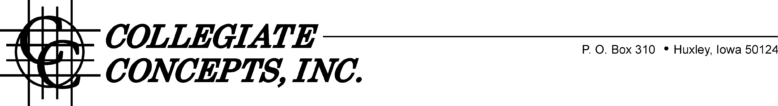

Dear Student,

In order to satisfy the demand for refrigerators and microwave ovens, the school has approved the MicroFridge® rental program. The MicroFridge® unit consists of a microwave oven and a refrigerator with separate freezer, all in one integrated unit. The MicroFridge® works off one electrical cord and meets all the school’s electrical and safety requirements.

Why should you be interested in MicroFridge®?

1.) Convenience: The MicroFridge® allows students to eat what they want when they want it. The True Zero degree freezer can store frozen foods – even ice cream – for extended periods. The refrigerator is auto defrosting, eliminating the chore of frequent manual defrosting. And you won’t have to squeeze it into the car at the end of the year.

2.) 100% Guarantee: If the MicroFridge® unit quits working for any reason (other than abuse), it will be replaced at NO CHARGE. No weeks-long waiting for service calls or sending the unit out for service.

3.) Low Cost: Total rental fee covers delivery, installation and pick-up. You won’t have to worry about transporting appliances back and forth from home. And, when splitting the cost with a roommate, you cut the cost in half. See order form for complete details on pricing.

4.) Safety: The MicroFridge® has patented circuitry built-in and works off one electrical cord to reduce energy consumption and prevent blown fuses or tripped circuit breakers.

The simplest and easiest way to order is to go to our secure website at www.CollegeFridge.com and place your order with a credit card (MasterCard or VISA). Or simply complete the enclosed form and mail it to us along with your check or credit card number for the total amount due. You may also call 515-597-2303 and use your credit card to place an order for your MicroFridge®. Prices will be slightly higher after the announced cutoff date of August 1st.

If you haven’t been notified of your student’s room location, just leave those spaces blank. If you and a roommate’s parents should both send in payment, the latter will be refunded in full at your request.

In order to insure that there will be a MicroFridge® unit available for you, we MUST receive your order by August 1st, 2016.

We are excited to offer this program to our students and look forward to their arrival on campus this year! Sincerely,

Collegiate Concepts, Inc. Rental Department

I accept your offer for the use of the MicroFridge® at Scripps College. My full payment is enclosed. I, the LESSEE, have read the terms and conditions of the Rental Agreement at www.collegefridge.com/terms and in mailing my order to CCI PO Box 310 Huxley, IA 50124; I understand and agree thereto.
Please furnish me with: ■ Previously Rented MicroFridge® Unit (Academic Year) @ $219.00 + $18.60 sales tax = $237.60
- I have enclosed a check or money order for the full payment
- I wish to charge the rental to (circle one) MasterCard / VISA

Signature: Card #: Exp: Print Name (Cardholder): Print Name (Renter’s Name): School: SCRIPPS COLLEGE School Email: Residence Hall: Room #: Phone #: Home Email: Home Address: Home Phone #: Cell Phone # City, State, Zip:

