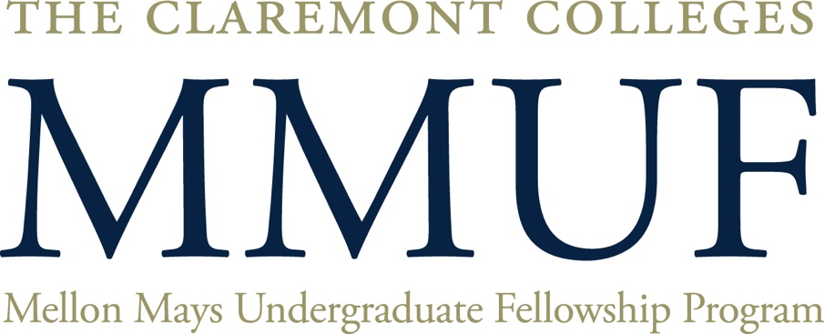



**INFORMATION SESSION**

**Friday, December 1st at 12:00 noon**

**Skandera/West Hall P103**

**PITZER COLLEGE**

The goal of the MMUF program is to identify and support underrepresented students, and others with a demonstrated commitment to diversity and equity, who are interested in earning a doctorate in the core fields of arts, humanities and social science and becoming future faculty. Learn more about the benefits of becoming a Fellow and how to transform the academy!

**For more information, contact the MMUF Academic Coordinators:**

**Professor Roberta Espinoza: roberta_espinoza@pitzer.edu**

**Professor Shahriar Shahriari: SShahriari@pomona.edu**

[**http://colleges.claremont.edu/mmuf**](http://colleges.claremont.edu/mmuf)